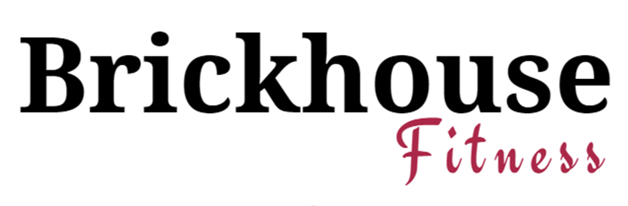

Informed Consent for Exercise Participation and Waiver Release

I and/or my child or children listed below, consent to voluntarily participate at Brickhouse Fitness and its various classes and fitness offerings. I acknowledge that the Programs may include activities that can be very strenuous, and participation in such Programs involves inherent risks, which could lead to bodily injury, impairment, disability, or even death. I understand the risks involved in my participation in the programs, and I agree to cease my participation in the Programs or any specific exercise, if I feel that such participation is too strenuous or places me at specific risk of injury.

In addition, I acknowledge that novel coronavirus (“COVID-19”) infections have been confirmed throughout the United States, including several cases in Virginia. In accordance with the most recent guidance and protocols issued by the World Health Organization (WHO), the Centers for Disease Control and Prevention (CDC), and the Virginia Department of Health, for slowing the transmission of COVID-19, I agree, represent, and warrant that I (nor my children) shall not visit or utilize the facilities, services, and programs of Brickhouse Fitness within 14 days after (a) returning from highly impacted areas subject to a CDC Level 3 Travel Health Notice, or (b) exposure to any person returning from such areas, or (c) exposure to any person who has a suspected or confirmed case of COVID-19, or (d) I experience symptoms of COVID-19, including, without limitation, fever, cough or shortness of breath, or have a suspected or diagnosed/confirmed case of COVID-19. I agree to notify Brickhouse Fitness immediately if I believe any of the foregoing access/use restrictions may apply.

In no event shall Brickhouse Fitness, its officers, employees, agents, or instructors, be held liable for any personal injury, illness, death, or property loss or damage sustained resulting from my participation in any/all activities in connection with Brickhouse Fitness programs. I also, hereby, release all those mentioned, and any others acting upon their behalf, from any responsibility or liability for any injury or damage to myself, including those caused by the negligent act or omission of any of those mentioned, or others acting on their behalf, or in any way arising out of or connected with my participation in any activities of Brickhouse Fitness or the use of its facilities.

I understand that Brickhouse Fitness does not provide childcare or any means to insure a child is not injured or becomes ill during the course of business. Parents bring their children at their own risk and are solely responsible for the health and well-being of that child/children, and any member who may be inadvertently injured by their child or children on Brickhouse Fitness premises. By signing below, parents release A To Z Dance Fitness, LLC., doing business as Brickhouse Fitness, all its officers, employees, agents, or instructors from any liability for an injury to a child, including those caused by the negligent act or omission of those mentioned in any way arising out of or connected with my participation in any activities of Brickhouse Fitness or the use of its facilities.

I also consent to having my photograph taken during classes for promoting and advertising purposes, and I further understand my photograph may be posted on the Internet on Brickhouse Fitness’s website and/or via social media websites such as Facebook, Twitter, YouTube, Instagram, etc.

Unless amended by mutual agreement, this instrument shall remain binding and in effect as long as I am a member or a participant in any of its classes or Programs.

I have read and I understand this document in it’s entirely.

Signature: Date:

Print Name: Birthday: / /

Address: City: Zip

Email: Phone:

Minor Child Birthday: / /

Minor Child Birthday / /

